Certificate of Appreciation
Sons In Retirement, Inc.
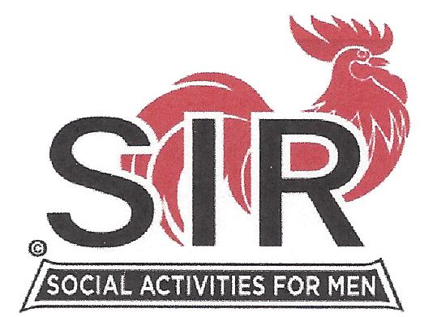
Branch No. 17

Dignity ~ Independence

To

[Name]

[Title or other descriptor
such as affiliation]

This certificate is presented in grateful

appreciation of your presentation on

[date]

______________
Gordon Boultbee
Big Sir - Branch 17

