Minutes of Sons in Retirement, Luther Burbank Branch 17
BEC Meeting via In-Person and ZOOM video, Epicenter, Santa Rosa CA
Thursday, August 18, 2022

Big SIR Gordon Boultbee opened the meeting at approximately 9:45 am.
Attendees: (voting members indicated by *)
Present: Big Sir Gordon Boultbee*, Little SIR Gary Bondi*, Assistant Secretary Steven Saulsbury*, Treasurer Al Petrie*, Director Barry Bialkoski*, Director Ken Johnson*, Immediate Past Big SIR George Traverso, Lunch Food Coordinator Glenn Seime, Picnic Coordinator Ted Scapeccia, Director Elias Zegarra*, Director Neil Wheeler*, Activities Chair Fred Rose, Rich de Lambert, Kurt Wehrmeister
Present Via ZOOM: None
Absent: Secretary Terry Freeman*, Assistant Treasurer John Gnam*, Director Bill Grafeld* Director Tom Lubas*, Webmaster Dennis Mangan,
Approval of the Agenda: A motion was made by Barry Bialkoski to approve the agenda for the current meeting, 2nd by Neil Wheeler, approved unanimously.
Secretary’s report for July: A motion was made by Steven Saulsbury to approve July 2022 Minutes, 2nd by Gary Bondi, approved unanimously.
Treasurer’s report (July 2022 Form 28 Income and Expense Report):
Treasurer Al Petrie explained there was a starting balance of $4140, receipt of $86 from half raffle, total expenditures of $329 ($133 for a new microphone, $24 for birthday award, $172 Guest expenses) also $120 returned to 3 people who couldn’t attend picnic because they were sick. The ending balance was $3820. A motion was made by Barry Bialkoski to approve the report, 2nd by Ken Johnson, approved unanimously.
Membership Report (Form 27):
Per Elias Zegarra, there were 84 members in Branch 17 at the end of July 2022. (9 new members, lost 7, net 2). Discussion about State’s new form. Gordon recommended we not go to the new form since the math on the new form is the same but harder to read. Motion to approve Form #27 for July was made by Neil Wheeler, 2nd by Barry Bialkoski, approved unanimously.

February Forms #27 and #28 sent to State:
Little Sir Gary Bondi confirmed the July Forms #27 and #28 were sent to State and Area Governor.

OLD BUSINESS
Lawn Sign Status and results of contest (Rich de Lambert and Neil Wheeler)
Rich requested to wait on the status update until the Luncheon meeting because he did not want to identify the winner of the sign contest at the BEC meeting. Gordon agreed.
They are continuing to move the signs around to different locations. They will be pulling the signs in and moving them to west side of freeway next Tuesday and Wednesday. They have not found lawn sign lost at picnic.
Member Survey (Neil Wheeler)
Neil reported modifications were made to the survey based on the initial results of BEC members. The survey is ready to send to all SIR 17 members. It will be sent out next Monday. Neil will discuss at today’s luncheon and recommend the survey be done online (George Traverso will attest to the ease of filling the form online). The goal is to have results by the next meeting. Neil is happy to help anyone who needs assistance. There are a few members who don’t have email. Neil will mail survey to them.
Inventory and Storage Space – Tabled till next month per Gordon
Feedback on Senior Day at the Fair Information Table (Neil Wheeler)
Overall the information booth at the fair went well. They talked to quite a few people and handed out brochures. Had a display board that describes SIR activity (refer to picture below). They haven’t received any applications yet. They did hand out applications to those that looked interested. Booth volunteers were brought in and out of the fair by drivers to avoid the $10 parking fee.
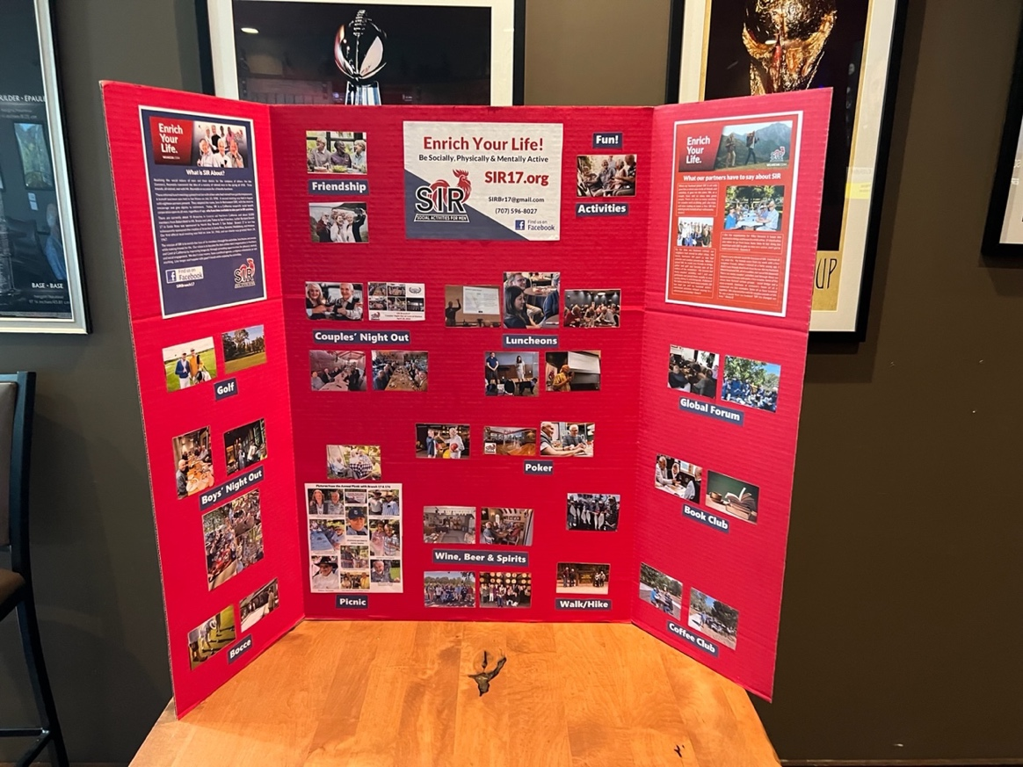

NEW BUSINESS:
New Member Orientation & 8/15 RAMP meeting
Per George a very good RAMP meeting was had (It was a long time coming and overdue). We have attracted new guys coming in but we need to keep them interested in the group. George feels that the sponsors need some kind of background to keep new people interested in the group. After the luncheon meeting today George and Rich will have an orientation / satisfaction meeting with members that joined since January (hopefully including sponsors). At the 8/15 RAMP meeting the committee agreed to meet the new members monthly after the luncheon. The meeting will only include newly inducted members (and their sponsors) and not guests. We will have 6 or 7 new members, not including sponsors, attending today’s meeting.
Book club - Neil will be sending out an email for an organizational meeting probably in early September.
New Member Approval: Tony Negri sponsored by Rich de Lambert. He is a former principal at Santa Rosa High School and past president of several organizations. He was adored by students and faculty per Rich. Tony contacted Rich about joining. After discussion a motion was made by Barry Bialkoski, 2nd by Gary Bondi, approved unanimously.
New Member Approval: Denis Lezotte was sponsored by Jim Gurke. He is a retired engineer with PG&E and retired educator. He is also a current owner of an antique store in Petaluma who not only sells antiques but rents out space to other dealers. George has known Denis for a longtime as a customer in his store. After discussion a motion was made by Neil Wheeler, 2nd by Barry Bialkoski, approved unanimously.
New Member Approval: Charles (Chuck) Baker was sponsored by Rich de Lambert. Per Rich we are very lucky to get Chuck into SIR. He was in Rotary about 45 years and was an outstanding member in fund raising, membership and other activities. He is experienced in video and set up (Backup for Neil). He is very hard of hearing. After discussion a motion was made by Elias Zegarra, 2nd by Barry Bialkoski, approved unanimously.
Approve Walking / Hiking activity: This is a new activity chaired by new member Stew Lauterbach. This is a procedural vote to get the activity covered by our liability insurance. After discussion a motion was made by Gary Bondi, 2nd by Ken Johnson, approved unanimously. It is now an official approved activity.
Bennet Valley Golf Course Restaurant Update: Glenn Seime met with Jessica Schroeder (707-582-2691) the new director of sales and marketing of the restaurant at Bennett Valley Golf course. The new name of the restaurant is “Bennett Valley Grill” with a capacity up to 175. Greg Anderson of Touchstone, manager over both golf course and restaurant, sat in on part of the meeting. Greg gave Glenn a tour of the kitchen. There are several items holding up the opening of the restaurant: 1) Health Department approval, 2) Need walk in Freezer fixed which can’t be done until mid-September, 3) Repair of ranges in Kitchen (City won’t approve new ranges). Glenn estimates restaurant won’t open until the end of September, early October. Glenn estimates the luncheon price will go up to $30-$35. Jessica will get back to Glenn with pricing. SIR 17 has a place holder for the restaurant luncheon starting in January 2023. Jessica came from Vintners Resort next to John Ash restaurant. Touchstone’s approach to the restaurant will be more family orientated than sports orientated. The current contract at the Epicenter is up at the end of the year.

Feedback on 8/11 Area 10 Zoom Meeting: Gordon attended the meeting on the 11th and there were only 3 Big Sirs that showed up with a couple of guys from state. They have recognized we are doing well with recruiting efforts thanks to Neil who is on some state recruiting committees. All area branches are doing a good job getting assessments in on time. Bob Nadel, Area 10 Governor, will be attending today’s luncheon to distribute recognition pins. Forms must be submitted on time throughout the year, otherwise liability insurance can be impacted. A new leadership program will come out sometime in the fall. Next Area 10 meeting is in November.
Adjournment at approximately 10:45 AM. A motion to adjourn was made my Gary Bondi, 2nd by George Traverso, approved unanimously.
Draft minutes submitted by Asst. Secretary Steven Saulsbury. Notes made from cell phone recording of the meeting.

