Certificate of Appreciation

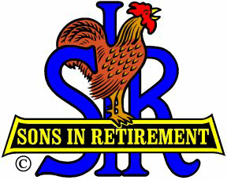
Sons in Retirement, Inc. Branch No. 17

Dignity ~ Independence

To

Pat Fuscaldo

Head Men’s Basketball Coach,
Sonoma State University

This certificate is presented in grateful

appreciation of your presentation on

January 19, 2018.

Robert Reuther
Big Sir - Branch 17

